Art Dealer Game: Art Dealer Game Project Documentation

Team Members

Pavani Pullela

Vineela Yadagiri

Nisanth Bandaru

Sainikhil Mamidala

Table of Contents

1.0 Introduction 2

1.1 Purpose 2

1.2 The Art Dealer Game 2

2.0 Process Model 4

3.0 Use Cases 5

3.1 Use Case 1: Level Selection 5

3.2 Use Case 2: Identify Math Pattern for K2 5

3.3 Use Case 3: Identify Math Pattern for Grade 3-5 5

3.4 Use Case 4: Identify Math Pattern for Grade 6-8 6

3.5 Use Case 5: Wrong Pattern Selection for K2 and Grade 3-5 students 6

3.6 Use Case 6: Wrong Pattern Selection for Grade 6-8 students 7

3.7 Use case 7: Correct Pattern Selection 7

3.8 Use case 8: Play Again and Quit Game 7

4.0 UML Model 8

4.1 Use Case Diagram 8

4.2 Deployment Diagram 9

4.3 Class Diagram 10

4.4 Activity Diagram 14

5.0 Customer Journey Map 16

6.0 Person 17

7.0 User Interface 18

8.0 Testing Strategy 22

8.1 Unit Testing 22

8.2 Integration Testing 22

8.3 Usability Testing 23

8.4 Validation Testing 24

# Introduction

## Purpose

This document describes the software design of the Art Dealer Game. This project is a computer simulation, which helps to K2 to G8 students to learn about computation, math concepts, computer science and computational thinking. This document described the required information for users and developers. This document contains only information that the development team felt needed to be preserved and maintained.

We view this document as being useful for teachers who teaches new math concepts like working with BIG data sets, interpreting something from multiple sources, over time etc. and for students, who would like to explore a more detailed example of the new math concepts. This simulator shows the progress of students on critical thinking and it will enhance the confidence level of student on new challenges.

## The Art Dealer Game

The Art Dealer Game is the pattern identify game, which is divided into three levels as K2, Grade 3-5 and Grade 6-8. This game is designed on math concept-based patterns. We have used traditional poker deck of 52 cards for designing different patterns. This game is 4 cards game. This game includes total seven patterns which divided into three stages. The first level is K2 level which designed for grade K2 students and this level includes three patterns as all four cards red, all four cards black and all four cards have same symbols. The second level is G 3-5 level which designed for grade 3-5 students and this level includes total 6 patterns as first level three patterns and all four card’s numbers are same, single digit prime number (i.e. 2,3,5,7), and addition of number of all cards is 21. The second level is little bit harder than first level. This game plays between art dealer and art seller. The paintings are 52 poker deck cards, which is randomly selected.

For level 1 and level 2, art dealer is computer so it always selects three deck cards automatically and based on selection of three cards, the are seller as student will predict the pattern. The third level is G 6-8 level which designed for grade 6-8 students and this level includes all 6 patterns of level 2 with even number combination pattern. This level is little bit different than other levels. This level is played between two students which takes role as art dealer and art seller respectively. So, here art dealer will choose the pattern and based on that he/she will select the three paintings and accordingly art seller has to identify the painting pattern. If art seller will select correct pattern, he/she will win the game otherwise he will get 3 chance to identify the pattern for level 1 and 2; and if he will not choose correct pattern after total 3 attempts, he will lose the game. In this game, if student will win the game or lose the game, he will get a chance to replay the game. This is very basic game but in future, we can add more complex patterns in it. The several use cases presented as part of the case study were selected based on the requirement.

# Process Model

The software development team will use the evolutionary process model as show in Figure 1 for Art Dealer Game project. This model is selected based on the requirement of game and iteration of design. This model is worked on the agile and iterative evolutionary process model, in which, we take first the whole requirement from the user and then enhance the product over the multiple iterations until we get final product. In each iteration, we make some design modifications and add some new functional requirements. The main goal of this model is to design the final product according to the requirement of user through multiple iterations so, the final product will come with less errors and high quality.

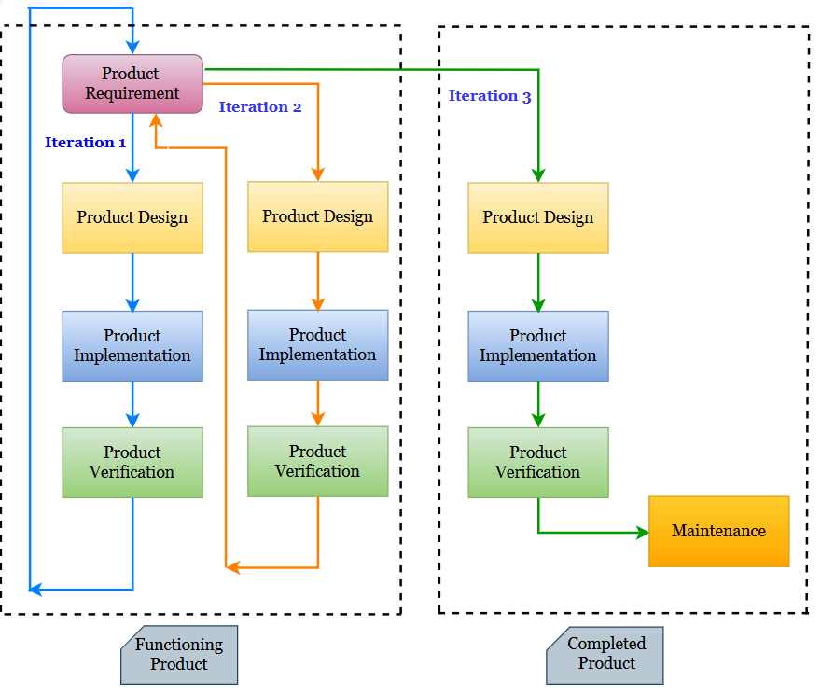

Figure 1. The Art Dealer Game evolutionary process model.

# Use Cases

To deliver working protype with minimal functionality, we have considered following eight use cases; which includes the use case name, primary actor, secondary actor, goals, preconditions, description of use case and acceptance criteria. In future, as per the requirement of user, we can extend the use cases.

## Use Case 1: Level Selection

**Secondary Actor:** Gallery owner as a player who want to play this game.

**Primary Actor:** Game

**Goals:** Game will allow to player to select the level of game according to student’s grade as level 1(K2) or level 2(G3-5) or level 3(G6-8)

**Preconditions:** Game must start with game logo and level options

**Description:** At the starting of game, game will allow to player to select the level and accordingly, a gallery owner will select the level and will play the game.

**Acceptance Criteria:** Gallery owner can select any level of his/her choice.

## Use Case 2: Identify Math Pattern for K2

**Secondary Actor:** Gallery owner as a player who want to play this game.

**Primary Actor:** Art Dealer as a Computer who choose the three random paintings as any three random deck cards

**Goals:** Gallery owner will select the fourth panting for art dealer which will be one of the following patterns of K2 level students as all four deck card’s symbols are the combination of diamonds and hearts or clubs and spades or spades only or hearts only or clubs only or diamonds only

**Preconditions:** Gallery owner select level 1(K2) and Art dealer must select three paintings (i.e. three random deck cards) automatically

**Description:** As a gallery owner, after selecting the three paintings by art dealer, I will select the fourth painting for art dealer based on his/her painting selection pattern.

**Acceptance Criteria:** Gallery Owner can select the fourth painting for art dealer according to the selected three paintings of art dealer.

## Use Case 3: Identify Math Pattern for Grade 3-5

**Secondary Actor:** Gallery owner as a player who want to play this game.

**Primary Actor:** Art Dealer as a Computer who choose the three random paintings as any three random deck cards

**Goals:** Gallery owner will select the fourth panting for art dealer which will be one of the following patterns of Grade 3-5 level students as revision of all the patterns of K2 students with some new patterns as all four deck card’s symbols are different but number is same or number is the combination of single digit prime number (2,3,5,7) or all numbers addition is 21

**Preconditions:** Gallery owner must select level 2(G 3-5) and Art dealer must select three paintings (i.e. three random deck cards) automatically

**Description:** As a gallery owner, after selecting the three paintings by art dealer, I will select the fourth painting for art dealer based on his/her painting selection pattern.

**Acceptance Criteria:** Gallery Owner can select the fourth painting for art dealer according to the selected three paintings of art dealer.

## Use Case 4: Identify Math Pattern for Grade 6-8

**Secondary Actor:** Gallery owner as a player 1 who want to play this game.

**Primary Actor:** Art Dealer as a player 2 who choose the three random paintings as any three random deck cards

**Goals:** Gallery owner will select the fourth panting for art dealer which will be one of the following patterns of Grade 6-8 level students as revision of all patterns of K2 and Grade 3-5 students with some new pattern as all four deck card’s symbols are different but number is the combination of even number

**Preconditions:** Gallery owner must select level 3(G 6-8) and Art dealer must select three paintings (i.e. three random deck cards)

**Description:** As a gallery owner, after selecting the three paintings by art dealer, I will select the fourth painting for art dealer based on his/her painting selection pattern.

**Acceptance Criteria:** Gallery Owner can select the fourth painting for art dealer according to the selected three paintings of art dealer.

## Use Case 5: Wrong Pattern Selection for K2 and Grade 3-5 students

**Primary Actor:** Gallery owner as a player who want to play this game.

**Secondary Actor:** Art Dealer as a computer who choose the three random paintings as any three random deck cards

**Goals:** If wrong pattern selection by gallery owner, game will give three chances to him/her to identify and select the correct pattern

**Preconditions:** Art dealer must select three paintings (i.e. three random deck cards) in level 1(K2) or level 2(G 3-5)

**Description:** If gallery owner will choose the wrong painting pattern, he/she will get three chances to identify the correct pattern. But after three attempts, he/she will lose the game.

**Acceptance Criteria:** Gallery Owner can get three chances to select the correct pattern at the time of wrong pattern selection.

## Use Case 6: Wrong Pattern Selection for Grade 6-8 students

**Primary Actor:** Gallery owner as a player who want to play this game.

**Secondary Actor:** Art Dealer as a player 2 who choose the three random paintings as any three random deck cards

**Goals:** Gallery owner will select the wrong pattern and lose the game

**Preconditions:** Art dealer must select three paintings (i.e. three random deck cards) in level 3(G 6-8)

**Description:** If gallery owner will choose the wrong pattern, he/she will lose the game.

**Acceptance Criteria:** Gallery Owner can select wrong pattern and lose the game.

## Use case 7: Correct Pattern Selection

**Primary Actor:** Gallery owner as a player who want to play this game.

**Secondary Actor:** Art Dealer as a player 2 or computer who choose the three random paintings as any three random deck cards

**Goals:** Gallery owner will select the correct pattern and win the game

**Preconditions:** Art dealer must select three paintings (i.e. three random deck cards) in level 1(K2) or level 2(G 3-5) or level 3(G 6-8)

**Description:** If gallery owner will identify and choose the correct pattern at any time, he/she will win the game.

**Acceptance Criteria:** Gallery Owner can select correct pattern and win the game.

## Use case 8: Play Again and Quit Game

**Secondary Actor:** Gallery owner as a player who want to play this game.

**Primary Actor:** Art Dealer as a player 2 or computer who choose the three random paintings as any three

**Goals:** After winning or losing the game, game will give a choice to Gallery owner to play again this game and according to choice selection as yes or no, game allow or denied Gallery owner to play again this game and replay or quit the game.

**Preconditions:** Gallery owner must win or lose the game in any level

**Description:** After winning or losing the game, gallery owner will have choice to select play again game. If gallery owner will choose the selection as yes against play again choice, gallery owner will play the game again otherwise he/she will not play game again and game will quit.

**Acceptance Criteria:** Gallery owner can play again this game against write ‘yes’ for play again choice otherwise he/she cannot play again this game and also, a game can quit against write ‘no’ for play again choice.

# UML Model

## Use Case Diagram

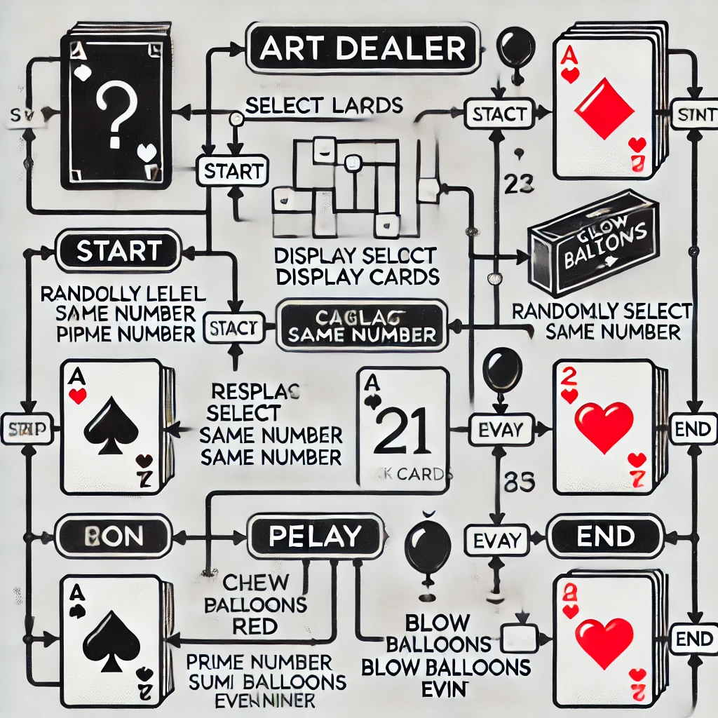

Figure 2. Use Case Diagram for the AR Room Designer System showing the six use cases for the project.

## Deployment Diagram

## 

Figure 3. Deployment diagram for the AR Room Designer System.

## Class Diagram

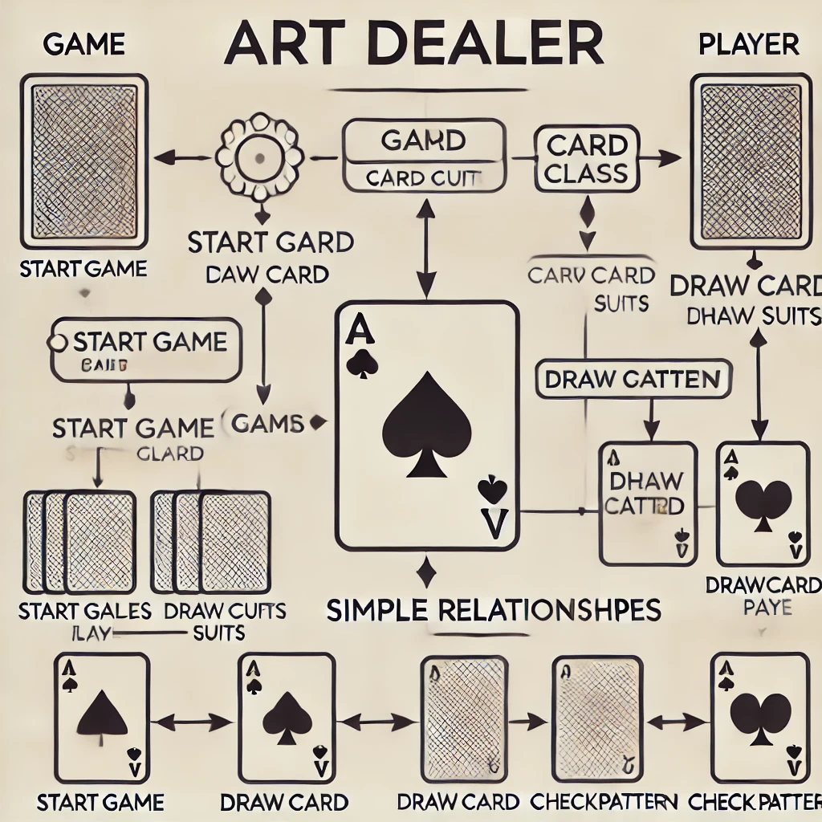

Figure 4. Class diagram for the AR Room Designer System

## Activity Diagram

The activity diagram shown in Figure 6 presents a more detailed description of the high-level behavior of the Art dealer game. Following the same process flow as the state diagram in the previous section, the user loads the system and **start a program to select levels**. If gallery owner will **select level 1 and 2**, gallery owner has to choose the correct painting for art dealer, who selected 3 paintings for him/her but if gallery owner will **select level 3**, player will be an art dealer or a gallery owner as per his/her choice. In the **level 3**, art dealer will choose the 3 paintings and based on the selection of paintings, gallery owner will identify and select painting for art dealer. If gallery owner will **select correct panting in any level**, he/she will win the game and get choice to **play again** this game but if gallery owner will **select incorrect painting** **in level 1 and 2**, he/she will get 3 turns to identify the correct painting and after that he will win/lose the game. For **level 3**, if gallery owner will **choose wrong painting**, he/she will get choice to play again this game.

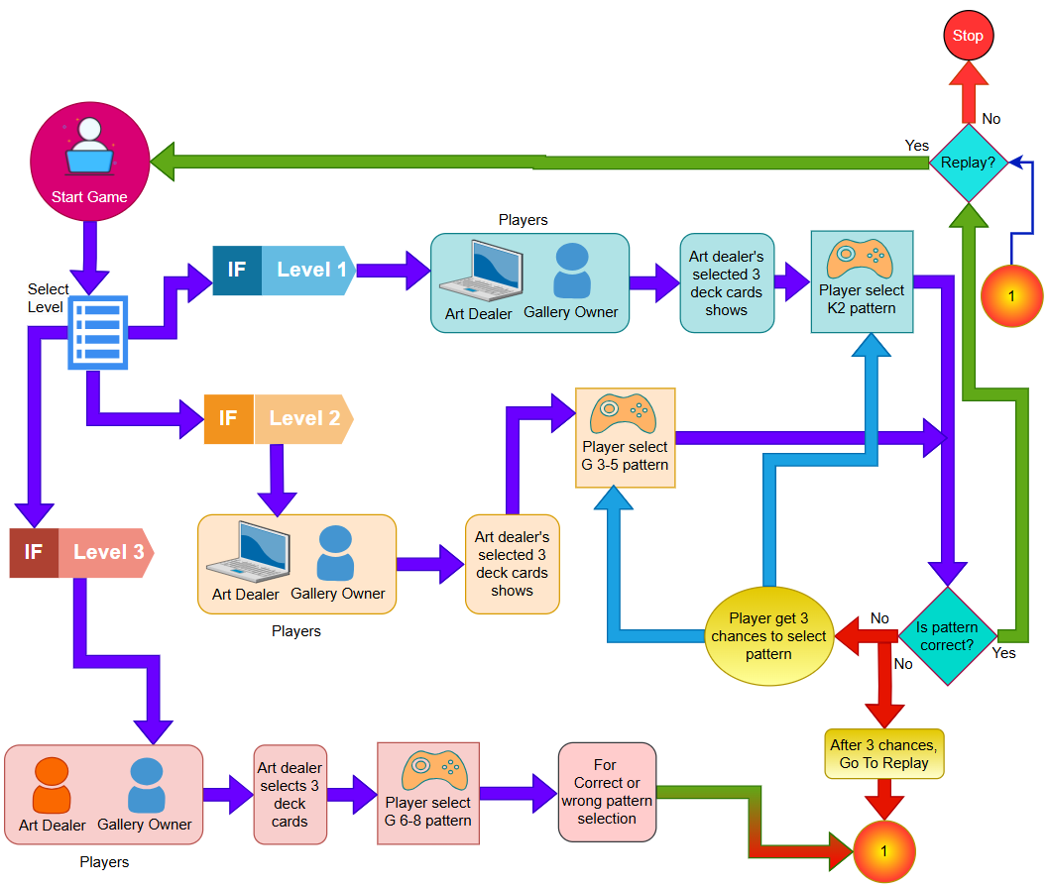

Figure 5. Art Dealer Game Design high-level activity diagram.

# Customer Journey Map

A detailed customer journey map for the Art Dealer Game created by the development team is used to understand the user experience of the customers (Figure 7). The main goal of player to find the correct pattern for art dealer to win the game. The waypoints clarify the likely steps of the player as he/she attempts to achieve their goal as win the game. In this project, developer team has used the relative validation message which helps player to win the game. It is important to keep in mind that further testing of the product may expose hidden threats for the client which would be important to update here in the active document.

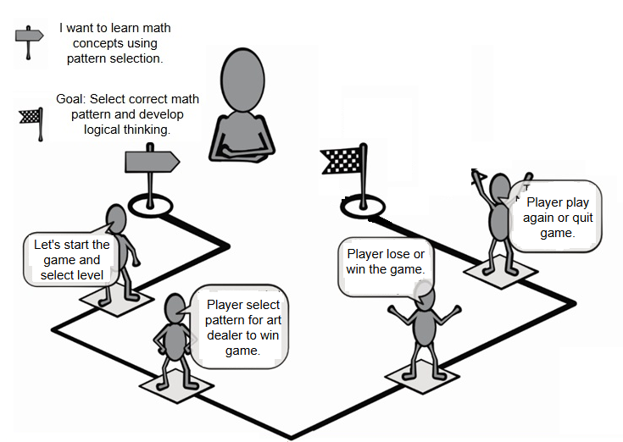

Figure 6. Customer journey map for the Art Dealer Game

# Person

A representative sample of a persona for the Art Dealer Game shown in Figure 8. It is important to have a different kind of personas with which to use to validate the project. In this project, we consider teachers and students of grade K2 to 8 as our personas who knows about the math patterns and able to identify the patterns very well way. A developer has to provide the quick guide to them to understand how to play this game and how to select the patterns according to their grade level. The developer has to consider the young age kids who might have difficult to adapting the system so accordingly design the quick guide.

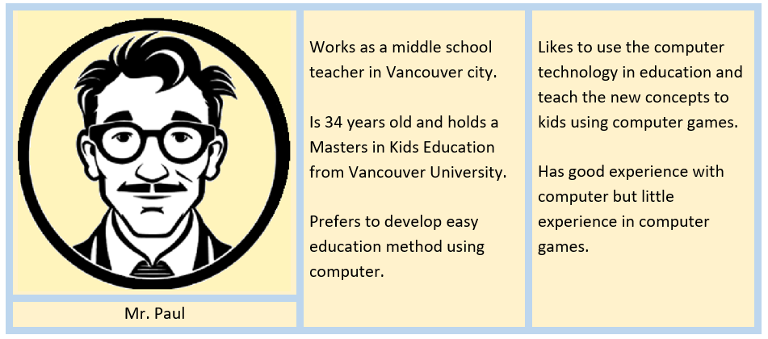

Figure 7. Sample person to evaluate the Art Dealer Game

# User Interface

The initial user interface for the Art Dealer Game is presented in Figure 9. The view shows the program home page with logo and level selection.

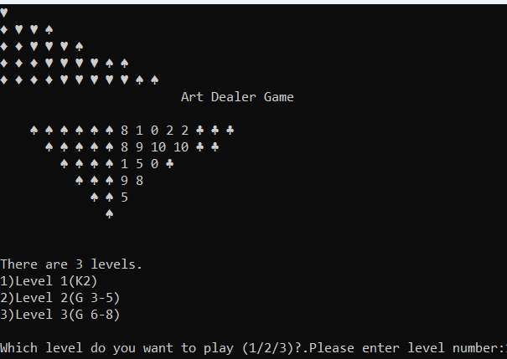

Figure 8. User interface for Art Dealer Game

As per the level selection, the program moves forward. This game allows to Player to select any level by enter the level number. Sample of level 1 shows in Figure 10 and winning game of level 1 in Figure 11. This game allows player to choose the pattern for all levels and also ask the player to continue the game or quit the game. The winning user interface is same for all levels.

A level 1 and level 2 user interface are same so we can consider the Figure 10 for level 3 also. Sample of level 3 shows in Figure 12.1 and 12.2, which is little bit different. The card will be selected randomly so it is different for each level and each game.

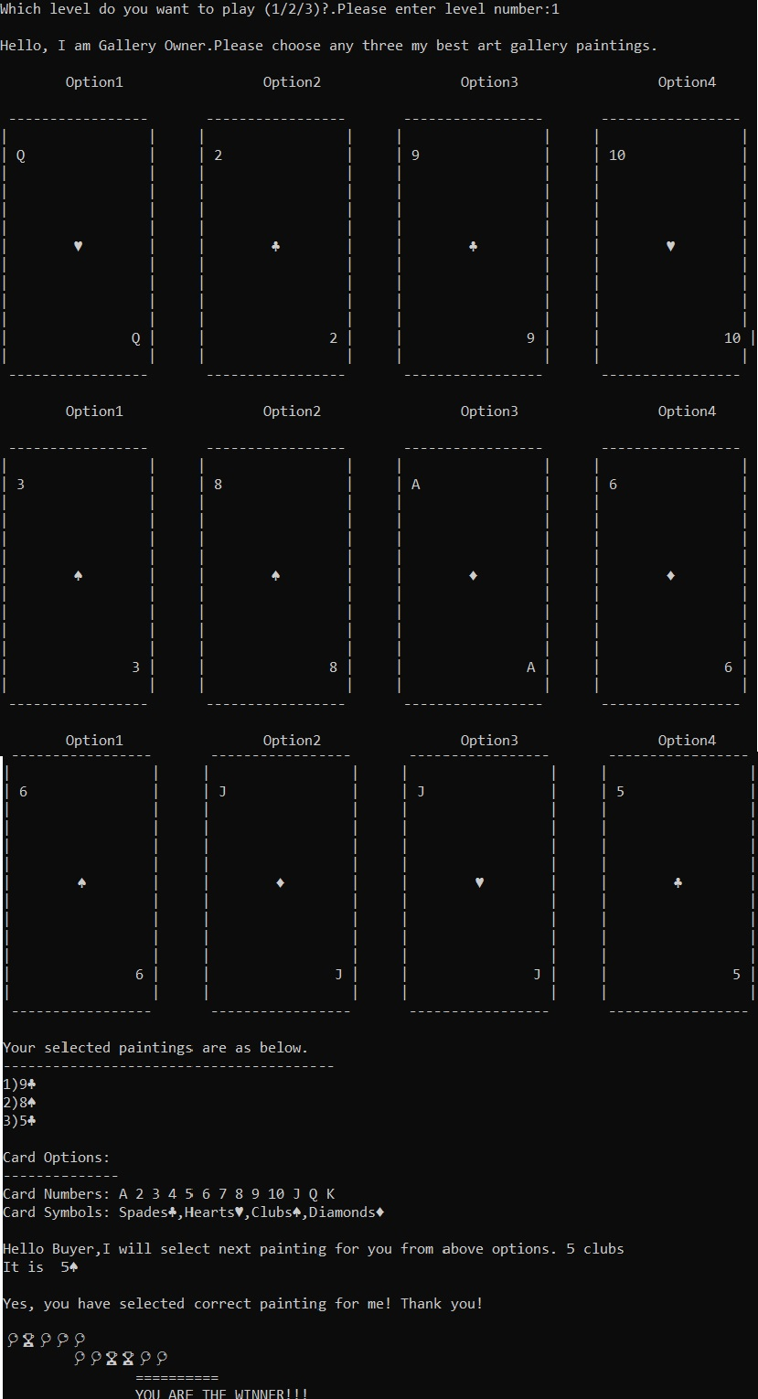

Figure 9. User interface of Level 1 for Art Dealer Game

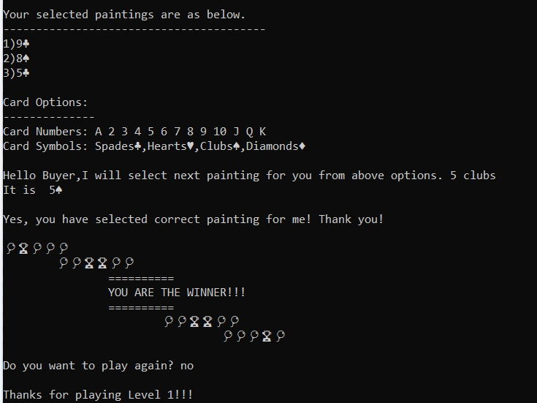

Figure 10. User interface of Level 1 winning game for Art Dealer Game

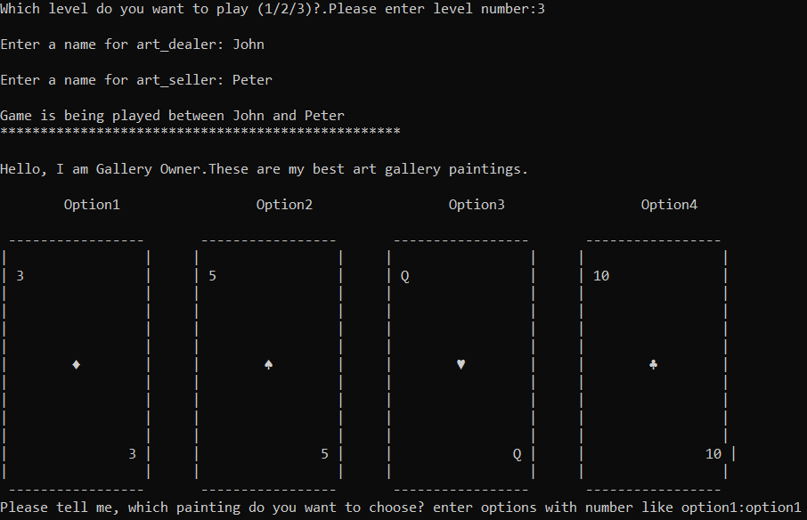

Figure 11.1 User interface of Level 3 for Art Dealer Game

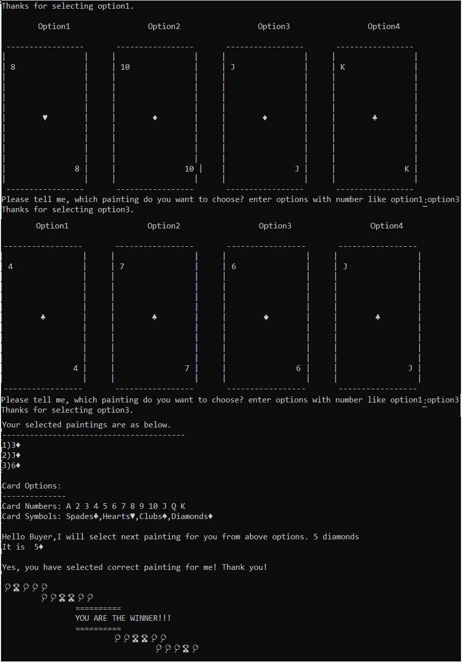

Figure 11.2. User interface of Level 3 for Art Dealer Game

# Testing Strategy

It is important to define the test strategy properly, which is used to create accurate test cases as well as to manage the project timeline. The proper test strategy will match the different phases of selected SDLC model. The test strategy is the outline of the testing of product and it includes the testing techniques and test kinds or levels used to test the products, which comply the quality standards and requirements of the client. As per the testing strategy of the development of the product, developer team have selected four categories of test cases as unit testing, integration testing, usability testing and validation testing.

## Unit Testing

In this testing, we test the smallest part or individual components or functions of software application which is in isolation mode. This testing method guarantees that each small code of the software executes as expected. Here, we test the small parts of software application so we can easily identify the fix bugs early and resolve it early which improves the quality of code and reliability of code. In this project, Unit testing includes white box and black box testing. In white box testing, developers verify the correct execution of the functional behavior of each small part/function of code which shows in Figure 4. As per the input, this testing checks the functionality of the output with internal design structure and code of the modules. In black box testing, we focus on the verify that the actual function outputs match the expected function outputs against pre or post conditions of each function. This project is not a modification project so grey box testing is not needed to check specific test cases or function or modules. In this project, the unit test includes the different test cases which includes test name and number to identify test case, brief description of the test and note actual or expected output of the test. If actual and expected output is same, test status is passed otherwise it is failed and showing the bug. We have written the tests in test table which has column and that indicates the respective user requirement or story, which associated with the test cases.

## Integration Testing

After performing unit test, all developers start integration testing. Integration testing is used to determine the correctness of the interconnection between two modules or functions of software or two software units. As per the name, this testing is exposed the faults in the interaction between two integrated units. This testing helps to detect and solve integration problems early in the development cycle. It dropping the risk of more severe and expensive issues later on. There are different approaches to integration testing such as Big-Bang, Bottom-Up, Top-Down and Mixed. As per the project requirement, a team decides to adopt a Big-Bang approaches because it is used for small projects and in it, all the modules are combined first and then functionality is verified. In this game project, we can easily identify the error and resolve it during integration testing so other approaches are not required. In this project, Integration testing will be performed by taking each use case one at a time and confirming the classes needed to achieve a use case interrelate properly. This testing will include a creation of a sequence of function calls which is used to complete each use case correctly and varying the sequences of function calls to show the developing prototype does not fail in unpredicted ways. Here, we performed testing like that way which will not introduce the new errors and make reliable and good quality product.

## Usability Testing

As per the name of the usability testing, it is used as user centered interaction design and evaluate an application on user perspective by testing it on user’s interface. This testing gives direct input on how the real users use the system. It is focused on how user use this application and, in this testing, we test the application with users who have experience or no prior exposure of this product. In this testing, we take scenario-based tests which shows how user will interact with the product. A usability testing helps in enhancing product overall functionality and user satisfaction.

In this project, we considered moderate usability testing and, in this testing, development team will provide eight use cases to user, who is the person of development team but with less experience of product because we have created this product for younger age students so we need the person with less experience of product. This use cases are designed based on the actual requirement of product and tell user to test all use cases Infront of developer, who is the part of this product development team. A developer will observe how user executes the use cases and what kind of difficulties, he faced during the testing of product and accordingly, he will note down the issues and modify the product. So, final product is user friendly.

## Validation Testing

In this testing phase, product is ready for releasing to end client. Here, a product is validated according to the actual product requirement of client. This testing is performed by the end client to check the product is developed according to the business needs of client. Test cases here will be selected to demonstrate all the functional, non-functional and other behavioral requirements against user viewpoint. A product owner will guide the end user for testing this product according to customer journey (i.e Figure 7). Preferably, the product owner will have before confirmed that the use cases are in fact what the system needs to accomplish to meet the customers’ needs. In validation testing, the developers are looking for to demonstrate that the system use cases as implemented deliver the product owner’s required functionality and meet the required level of quality.